

CST 2120 – Web Applications and Databases

Aryan Kawade

Student ID – M01042658

Submission Date – 30/10/2025

**Table of Contents**

Table of Contents

Project Overview 3

Login / Register System 4

The *ESTEEMED LEADERBOARDS* 5

The Webpages 5

The Index Page: 5

The Login and Register Page: 5

The Game Itself: 5

The Leaderboard Page: 5

File Structure 6

Features 11

1. Asset Inclusion 11

2. Classes 11

The Player Class: 11

The Enemies Class: 11

The Gems Class: 11

The GameManager: 11

The BGMusic: 11

3. Standalone Functions 12

4. Modules 12

5. Registrations and Login Checks 12

6. Local Storage and Session Storage 12

7. Advanced Enemy Avoidance 12

8. Visual and Auditory Cues 13

9. Procedural Grid Map Generation 13

HTML Validations 13

Extra Minor Improvements and QOL 15

Future Enhancements 16

Conclusion 16

References 17

# Project Overview

In this project, I made a game called Gem Collector in HTML-JS. This Game is an open world looter where you as the player run around collecting gems which acts as your score.

Meanwhile the different variants of enemies constantly chase you across the map. The enemies are:

* Ant – Fastest Enemy, Deal 1 Dmg;
* Bat – Mid Speed, Deal 5 Dmg;
* Bear- Slowest Speed, Deal 10 Dmg;

These enemies are a part of a common class system in game.js. They also include complex self-written (not an external module) AI pathfinding and kin avoidance.

In Layman’s Terms they can space themselves out in small gaps to avoid overlapping and causing mass damage to the player at once, if caught.

But, lets talk about the player, As the player you are trying to survive since it is the survival of the fittest in that dense forest type world. The player has animations which help identify which direction you are going and facing clearly. You also have a score and health system. The health doesn’t recharge since that would make it too easy, life ain’t supposed to be easy.

The gems are the score, each one collected increases your score by 1 point, which earn you a spot in our *ESTEEMED* *LEADERBOARD.* The player also has some hurt sound effects which play when you get hurt. The dmg is as explained earlier.

The Gems are spawned constantly in that world, you are lucky to be the only one to have found it out, since its only single-player right now. They also spawn in truly random spaces. All the game assets are included neatly in the Assets Folder.

Go Ahead and Conquer the world, one gem at a time….

# Login / Register System

This project includes Login and Register techniques. This technique gives a true identity to you as a player. You need your:

1. Nickname – Everyone has a Gamertag now…
2. Phone Number – So that we can contact the IRS if you steal any gems from the game. (It is a joke for legal reasons.) It requires exactly 10 numerical digits.
3. Email-ID – A computers Mail Box. You can use any email-id as long it has @ and .com.
4. Password – So that we can safe-keep your gems. For security purposes needs to be 5 characters or more with uppercase, lowercase, and numerical digits.

All these metrics need to be fulfilled in order to be proud of your high score in front of our *ESTEEMED LEADERBOARD.*

Finally, after you have registered all this information gets stored in a very unsafe location sadly, in the Local Storage. The local storage is visible / accessible to anyone that uses your computer, that’s why it’s considered extremely unsafe. Give you personal information on your own risk, since only your laptop can see it.

To actually access your registered ID, we now use another unsafe place to store you login ID, the Session Storage. It is unsafe for the same reasons above. But it gets logged out the moment you leave our site, so your secret is safe with us. Unless you have tech savvy parents. RIP…

We also have the ability to welcome guests, the players who don’t want any glory and only chase pain. Although they can come and leave freely, we have restricted their scores so that neither can they see your score nor can you see their scores in our *ESTEEMED LEADERBOARDS*. They do get saved just for fun purposes, definitely no other reason.

# The *ESTEEMED LEADERBOARDS*

The one and only king of gloating to your friends. The glory this offers is that it can show the highest of highest of your scores, while hiding the smaller score behind it for you to show your magnificence in this game to your friends.

Basically, it saves all your scores but it showcases only the highest one.

This is also saved in the Local Storage.

# The Webpages

We have 4 different webpages to properly showcase the one game.

## The Index Page:

The one who stands at the front. It is the first page to greet you when you open my website. It includes the information of your players world and a big logo for authenticity.

## The Login and Register Page:

The second once that is the only gate between the guests and your gems. Both of them are on the same page, just in different boxes for versatility.

## The Game Itself:

The main attraction and they sole reason for this project. It deserves it own page at the very least. It includes a canvas in HTML which draws the entire world of 6400 x 6400 pixels. Quite a large world for just one person and a horde of vicious predators. This also includes a pause functionality just because I am gracious. It will showcase your score and health at the top, just don’t tell the player inside, he would be very confused what are you saying since it doesn’t know any languages.

## The Leaderboard Page:

This page was explained in its very own heading up top, just read that honestly.

# File Structure

For file integrity purposes DO NOT RENAME OR CHANGE THE FILE LOCATIONS.

Reference to the locations of the files:

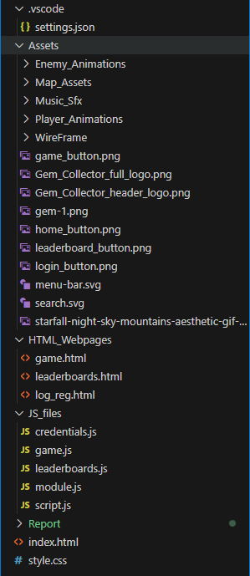

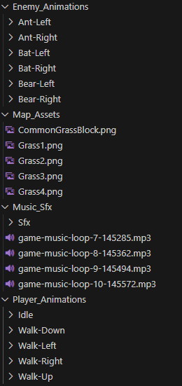

To Run this project, you will require VS Code due to requiring a live server. It will not run solely on the index page, since it contains modules scripts which give errors if not properly referenced which is done by the live server.

The website looks like this…

1. Index :

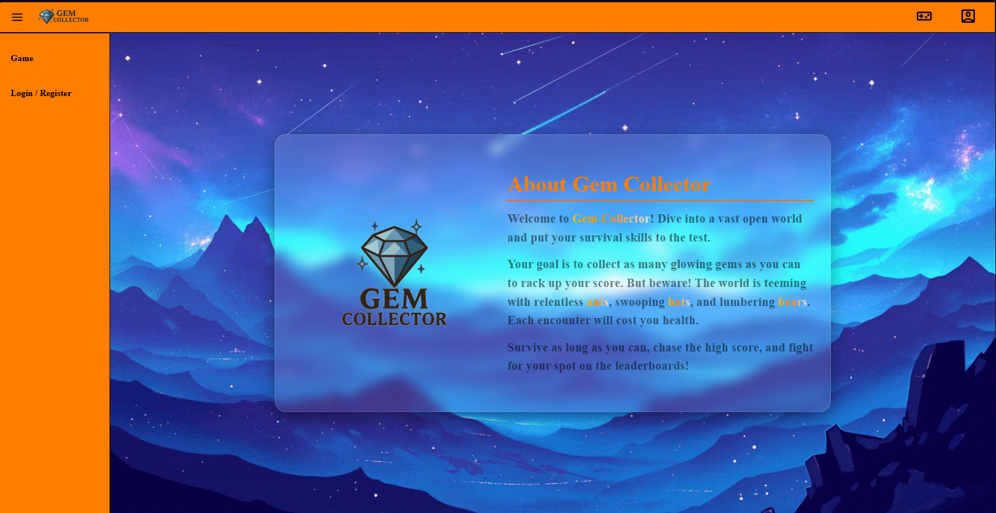

The Sidebar is included in every page so not including in every screenshot.

1. Login / Register:

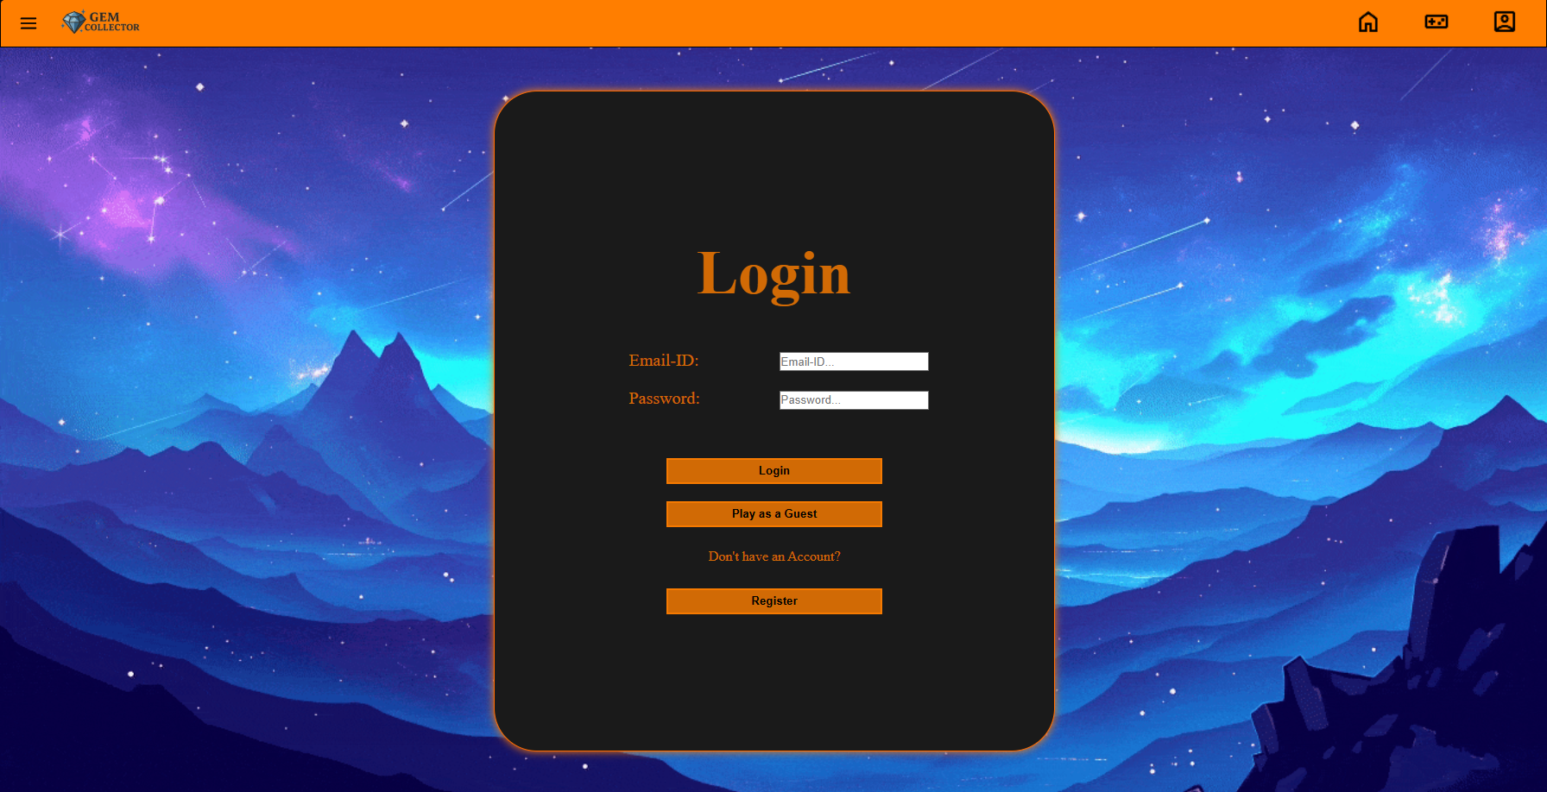

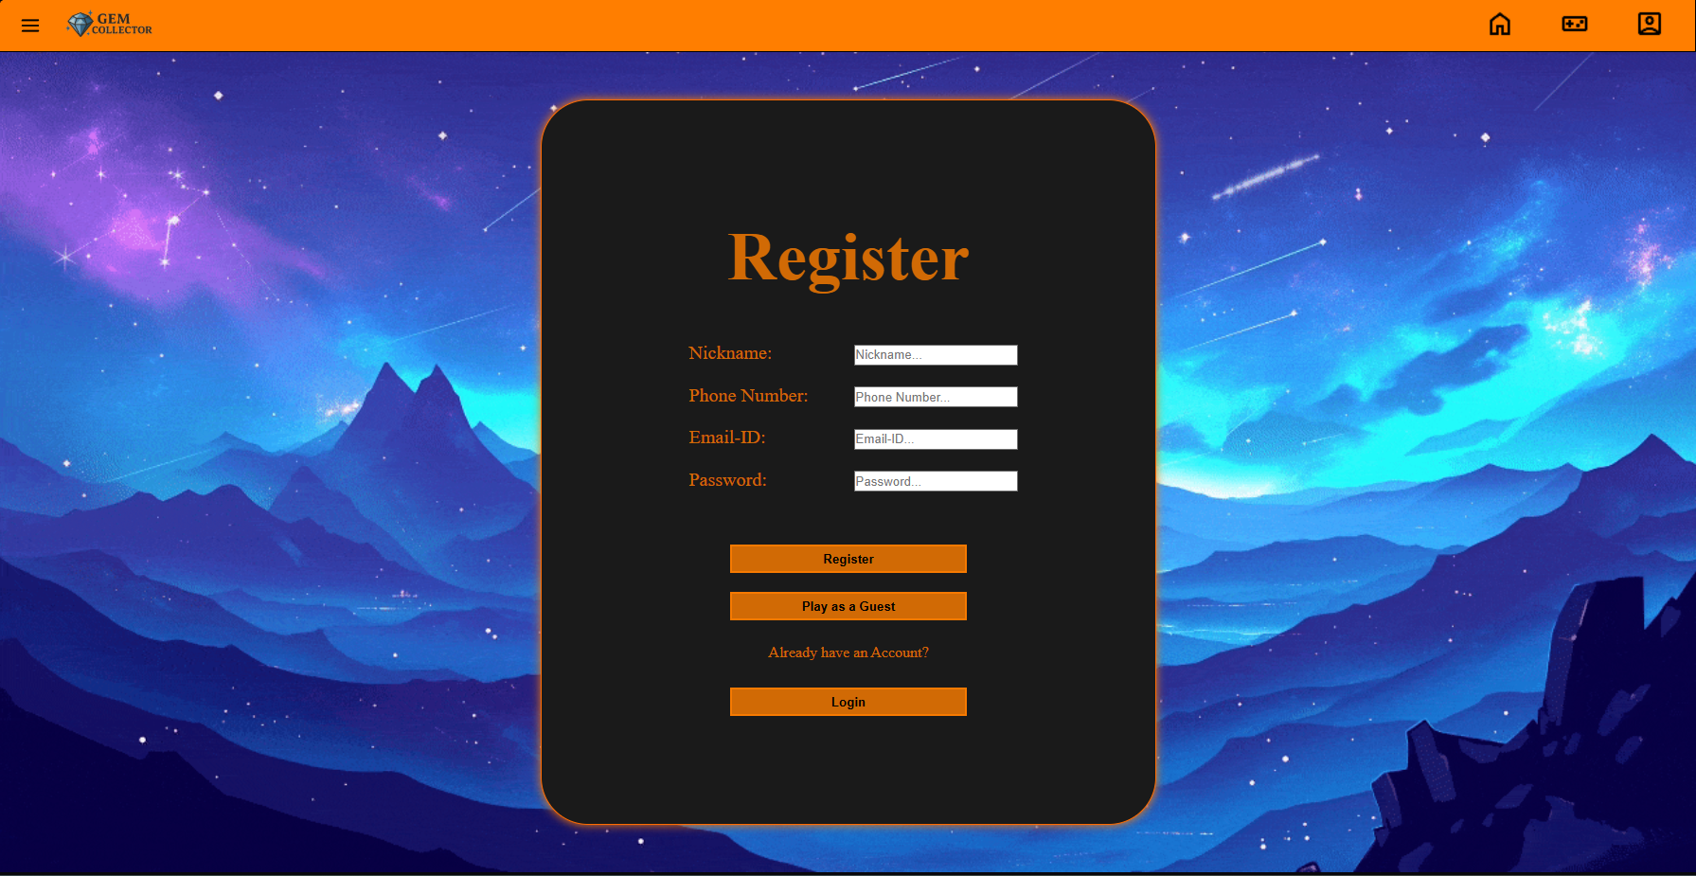

On pressing the third button they switch boxes without needing to change pages or reload.

1. Leaderboard:

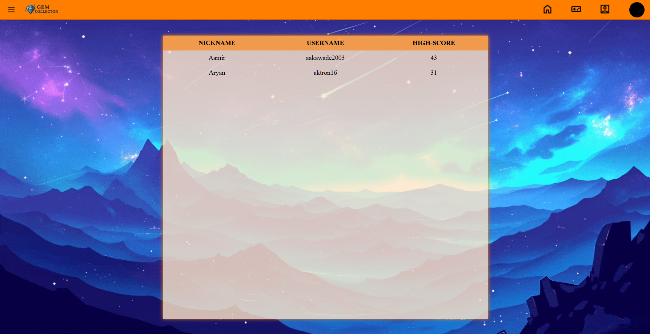  
Only accessible if you are logged in, as observed by the avatar at the top right of the screen.

1. Game:

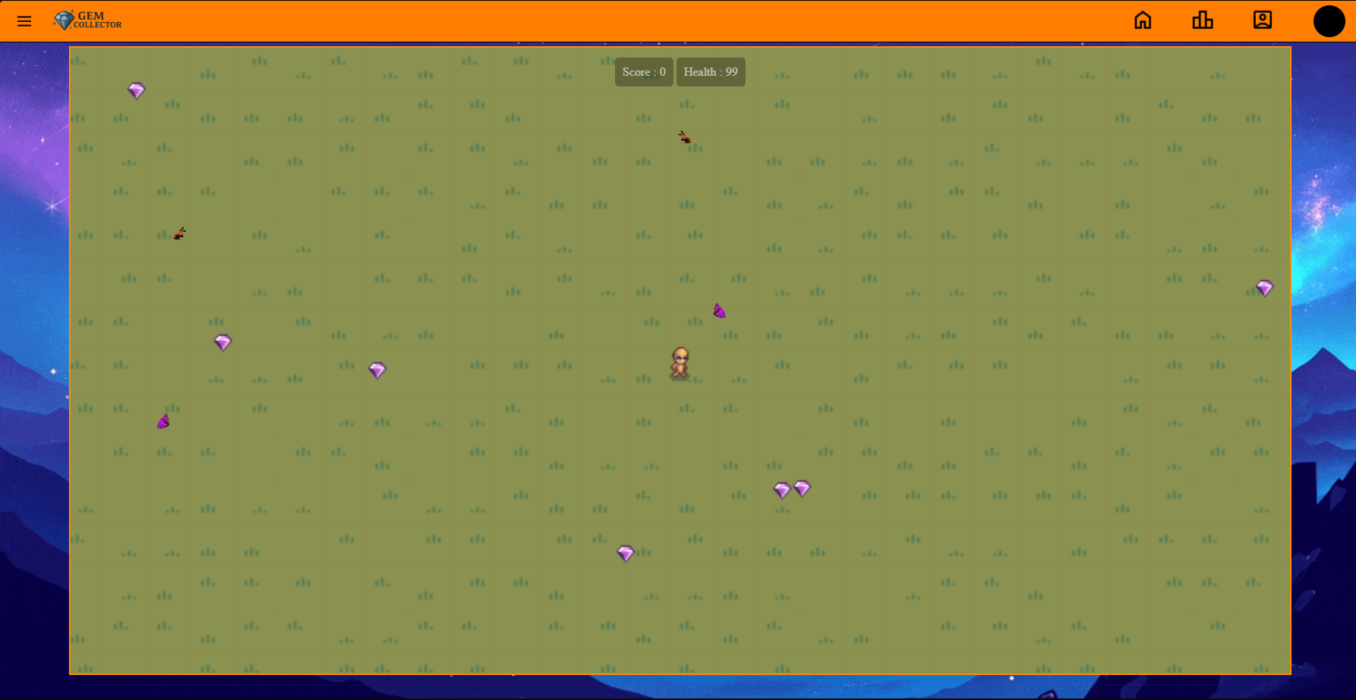

Look at my man posing, say cheese.

# Features

## Asset Inclusion

This project is all enclosed in the files. There is no external API importing from the web, including the icons.

The assets also include some free character and enemy sprites taken from Craftpix.com.

## Classes

The game.js file has multiple classes each doing their own thing. All of them have constructors which help call the function and initialize the class functions. Few of them are:

### The Player Class:

Some functions are Get(health) , Set(Health), dmgplayer(), move(dt), updateAnimations(dt), collisionDetection(obj).

### The Enemies Class:

Some functions are followplayer(dt, player), updateAnimations(dt), checkcollision(player), enemyAvoidance(enemies).

### The Gems Class:

Functions are checkCollected(player), draw().

### The GameManager:

The Boss of the program that tells where and what to do. Functions include spawnone(obj), spawnall(obj), update(player), draw(), followplayer(dt,player).

### The BGMusic:

To give inspiration to the player to do better and not bore them. Functions include playcurrent(), nexttrack(), pauseTrack(), resumeTrack(), etc.

## Standalone Functions

This column features as it says the standalone or ones too vague to group together in a class. This contains a lot of functions some which draw the background grid for player reference, Add the Grass tile maps, Pause the game, Saving the score, etc.

## Modules

A separate file to send common variables to the other js files. It is like a backpack of variables and functions used to make sure the same is not imported multiple times.

## Registrations and Login Checks

In the credentials.js file you can see these checks. It’s just a set of if clauses checking according to a regex and returning if found true.

The checks are:

* Phone Number: Has to 10 Numbers
* Email: Has to have @ and .com
* Password: Has to include 1 Uppercase, 1 Lowercase, 1 Number and minimum 5 characters.

## Local Storage and Session Storage

They can be found in the modules. They are the centralized variables that get exported everywhere in the js files.

Named User Current, Users, Leaderboards.

## Advanced Enemy Avoidance

The Enemies don’t just overlap they keep social distancing from each other so that they can be properly identified. They also follow the player till he dies. Talk about till death do us part.

## Visual and Auditory Cues

The Game includes Animation Assets and Auditory cues like when you get hurt. It also soothes the player and gives inspiration to keep on dodging the enemies.

## Procedural Grid Map Generation

No two maps will ever be truly same. It includes random grass grid map generation. Whenever the page is reloaded or the game is restarted it generates a new grass map which makes sure it feels new and not stale.

# HTML Validations

These are the .html validations given by W3C validator.

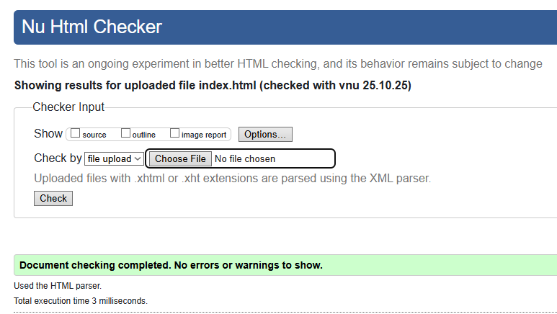

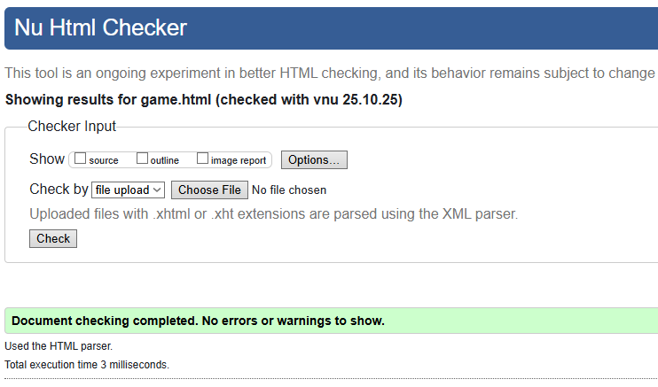

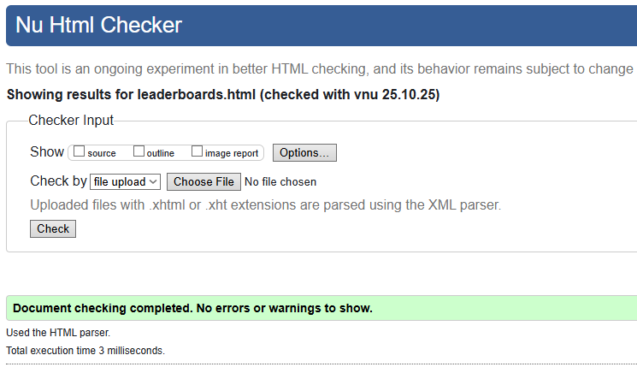

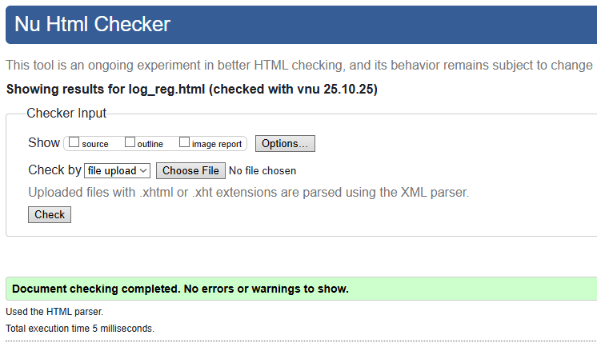  
  
There are enough creatures in the game, I don’t need any more bugs.

# Extra Minor Improvements and QOL

In my CSS, I have included the use of variable colors which was used to create the complimentary website colors.

In my game.js, I have custom coded a camera script with some help from AI since this is not a simple thing. This camera follows the player to and fro recording his life story at any given moment.

Fixed Frame Rate (delta time) to ensure even a 1999 laptop can run my game (not sure, try at your own expense). This decreases lag by a lot since there is minimal difference between devices.

Intro Liquid Glass Box is a minor QOL feature. It just looks good.

# Future Enhancements

This Game is market ready release, but after swallowing my ego I noticed room for improvement.  
The Player could evolve in future updates by making weapons to defend instead of just running away. Also, since he is running continuously, he can be nerfed by giving a stamina bar.

The Enemies could get their very own health bars. They can also receive incremental speed as the player could upgrade speed.

Power-Ups could be sponsored by the user to the player to reaffirm that he is not alone.

Terrain Improvements… Include new maps?

Add custom collisions like a house for him. Could also give him new skins.

Mini-Maps for the player to figure best way to get to next gem without getting hit.

Personally, not getting paid to do all this stuff, perhaps….

# Conclusion

Let me conclude this report by saying this has been a great learning experience for me. I am progressing towards my personal goal of creating this game in different coding languages. This game has already been created in Godot and Unity with massive improvements.

This project gave me an insight on how is it to create a game from scratch.

AI also helped me a ton when I couldn’t figure out the syntax for certain features.

The time allocated for this project was quite small compared to the project scale. Since this was a learning objective, I am now ready for future prospectives in this field and language.

# References

Github - <https://github.com/Aktron16/Html_JS_Game>

ChatGPT AI

CraftPix - <https://craftpix.net>

PineTools – To split my Sprite Sheets  
<https://pinetools.com/split-image>